Staff Data  
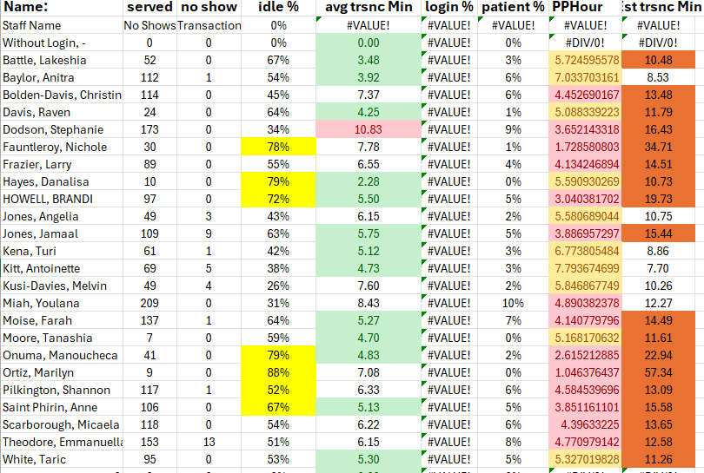

Notable decline in phlebotomy performance last week. Can you please let me know what happened. I'd also like to know your plans on addressing. Please answer by 5pm Tuesday (7/15/25)  
Last 4 weeks of performance:

|  |  |  |  |
| --- | --- | --- | --- |
| 57% | 70% | 75% | 66% |

Hello John and Ugochi, We had a fairly significant change to our KPI metrics over the past 10 days. It encouraged me to take a little bit of a deeper look. I'm hoping that you can do a little closer looking and let me know what your plans are to address. What I see on my end it is mostly centered around 2nd shift. Specifically around the "collect to in lab" numbers. Though some days the in lab to result are also lagging. Ugochi L Ndubuisi I'm hoping that you especially can lean in here.

Here are the notes from my investigation. Let me know how I can support

Problem:

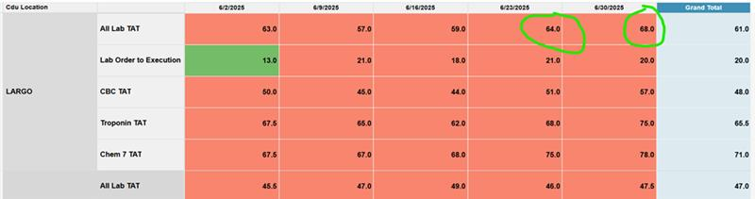

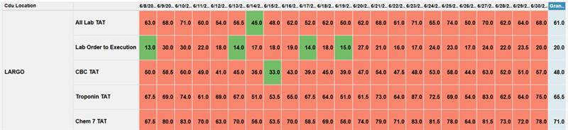

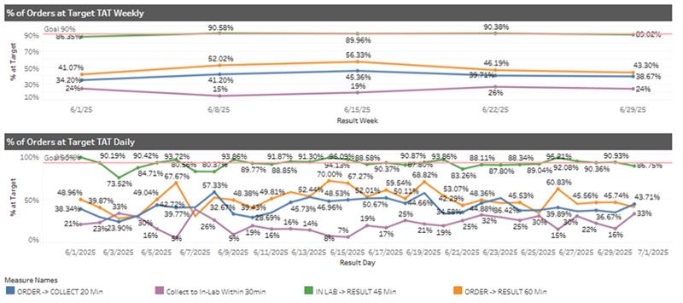

KPI data has increased over period 6/19-6/30/2025.

Deeper observations:

6/21, 6/23, 6/25, 6/27 and 6/30 all greater than 65m

             Greatest increase to chemistry/Troponin, however delays on all tests exist.

6/14, 6/19, and 6/26 all with less than or equal to 50m

6/21 (KPI 68):

* Power disruption to UPS system that caused a 2-hour IT downtime during early AM hours
  + Does not appear to have caused issues past the morning.
* Extended collect to in lab time, especially during 2*nd* shift.
* Lower volume (Sunday)
* Regular staffing
  + Jackie/Boyet OVN
  + Booker/Francis AM
  + Tracy/Sam PM

6/23 (KPI 71)

* Extended collect to in lab time, especially during 2*nd* shift
* Extended in lab to result time, especially during 3*rd* shift
* Fire Alarm, all staff and members evacuated for 30 minutes (6:00pm-6:30pm)
* Regular staffing
  + Boyet/George OVN
  + Emily/Francis/Ingrid AM
  + Albert/Sam PM

6/25 (KPI 74)

* Extended in lab to result time especially during 2*nd* shift
* Extended collect to in lab time especially during 2*nd* shift
* Regular staffing
  + Boyet/George OVN
  + Lesile(float)/Francis/Ingrid AM
  + Tracy/Albert/Sam PM

6/27 (KPI 70)

* Extended in lab to result time especially during 2*nd* shift
* Greatly Extended collect to in lab time especially during 2*nd* and 3*rd* shift
* Regular Staffing
  + Boyet/George OVN
  + Emily/Francis/Ingrid AM
  + Tracy/Sam PM

6/30 (KPI 68)

* Extended collect to in lab time especially during 2*nd* shift
* Short staffing on OVN shift. Float coverage on 2*nd* shift
  + Goerge OVN
  + Francis/Ingrid/Alber AM
  + Tracy/Lionel(float) PM

Analysis:

* Regularly extended collect to in lab times for 2*nd* shift.
  + Workflow on specimen in-processing may be an issue
* Differences in staff productivity are possible
  + Days <50 all lack Sam on schedule
  + Days >65 with one exception have Sam on schedule
* A significant number of “off site” Stats arrive after 6pm on a regular basis.

Recommendations

* Workflow analysis by Managers, especially during 2*nd* shift
  + Assess Sam’s workflow for opportunities of improvement in particular.
* Part time 2*nd* shift MT/MLT should be posted ASAP (I am working on this)
* Work with AUC partners to identify possible gaps in AUC collection workflow
  + Reports of samples coming to lab with no active orders
  + Tests being ordered along different pathways (in lab vs clinic collect vs not dispatched/collected by nurse)

AUC order to lab results:  
